Programming Assignment 1 Report

(a) What I built:
I built three hash map data structures in C++, each incrementing features of a Swiss Map, in order to showcase performance differences with each added feature. I also created a C++ file to test the performance of the three maps and comparing them amongst each other and std::unordered_map and boost::unordered_flat_map. Lastly, I created a file to plot the results on graphs in Python.

All three maps use std::vector as the underlying storage, with each cell storing a key value pair. The first map, OA_Map, is an open addressing map with no further functionality of a Swiss Map. Scalar_Swiss_Map is an extension of OA_Map, however, instead of comparing keys on every comparison, a control vector is created, storing the seven high bits of the hash. Swiss_Map is an extension of Scalar_Swiss_Map with SIMD (single instruction multiple data) implementations to speed up the traversal of the control vector.

In all three maps, keys are hashed, and the index is calculated by taking the hash bitwise & (capacity - 1), which is used to find where to insert the key, or to find the key already present in the map. In the case of collisions, linear probing is used to find the next available slot. Once the load factor exceeds the maximum load factor, a rehash function creates a new vector with double the capacity and inserts all the old keys into the new vector. Iterators with overloaded operators are also included as a nested class.

Textbook implementations usually utilise the hash modulus the largest prime lower than capacity. I chose to use the bitwise & operator, and keeping capacity as a power of two, since the modulus function is more expensive as it requires the CPU to do division operations. Keeping capacity as a power of two makes (capacity - 1) have a suffix of all set bits. Bitwise &ing this with the hash keeps the lower (k - 1) bits, where $2^{k}$ is equal to the capacity. This gives possible indexes of the range 0 to (capacity - 1). The issue with this approach is that if the hashing function has low entropy in the lower k bits, then collisions are more likely. To account for this, SplitMix64 was used as the hashing function which incorporates the avalanche effect, ensuring that flipping any input bits modifies around half the output bits, thus keeping entropy high. Lastly, the maximum load factor is configurable and required to be passed onto the constructor. I did this to explore the relationship between maximum load factor and performance for each map, however, maximum load factor is usually constant in other map implementations. The maps are simplified in many respects. Tombstone slots are never reused, and are only removed upon rehashing (5.2 $ Linear Hash Table: Linear Probing, n.d.). The size of the maps includes tombstones instead of active keys. Rehashing always doubles the capacity, whilst other implementations usually reduce the size based on the number of active keys.

OA_Map is a simple open addressing map that implements all that was previously stated, with two values of the same type as the key of the map, for an empty sentinel and deleted sentinel passed into the constructor of the map. After calculating the index using the hashed key and the capacity of the map, the slots vector is iterated through until either a slot with the same key is found, or an empty slot, whichever comes first. An empty slot signifies that the key is not present in the map, as it would’ve been inserted at that slot. Slots containing other keys, or that have the deleted sentinel are skipped over. Some simplifications are that slots are initially filled with a sentinel key and a default constructed value, and that erase doesn’t destroy values but only changes the key to a sentinel.

Scalar_Swiss_Map splits the hashed key into h1, which are the lower 57 bits, and h2 into the which are the higher 7 bits. h1 is used identically to the hash in the OA_Map, however, h2 is used as the value for the control vector. The control vector allows comparisons to only be a single byte, instead of a whole key, which, for large objects like strings, is costly. Keys need to only be compared when the control bytes match. Assuming evenly distributed entropy within h2, there is only a 1/128 chance of two unique keys having identical h2 values. Thus false hits are rare, which lowers the number of costly equality comparisons significantly. Moreover, sentinel values do not need to be provided, as they are inserted into the control vector instead of the slots vector. The empty sentinel has its largest bit set and the rest unset, and the deleted sentinel has all its bits set. Thus, filled slots only correspond to control bytes with the highest bit unset. When a key is removed, we do not need to modify the slots vector, but just change the sentinel in control. In OA_Map, we only needed high entropy in the lower end of the hash, however, it is more important in Swiss Maps to have evenly distributed entropy, as low entropy in the top 7 bits leads to control vector collisions, whilst low entropy in the lower 57 bits leads to slots vector collisions. SplitMix64 evenly distributes the entropy so it is sufficient for these implementations. Some simplifications are that erase doesn’t change slots’s key or value, only the control byte is changed to the sentinel for deleted; and that there is no end of table sentinel, instead bounds are checked by comparing against the end Iterator.

Swiss_Map expands on Scalar_Swiss_Map through using intrinsic functions to compare 16 control bytes simultaneously. h2 hits are compared, and after, if none of the keys are equal, the 16 bytes are checked for an empty sentinel control byte. If one is present, then the key is not in the map, utilising the same invariant that if the key was in the map, it would’ve been inserted at that empty slot. To enable checking 16 control bytes simultaneously, the control vector’s size is set to capacity + 16, with the first 16 control bytes always being copied into the last 16 control bytes. This is done to prevent an out of bounds access as the 16 bytes must be loaded contiguously, so without it, searching a group near the end of the vector would overflow. Some simplifications are that the minimum capacity must be 16, linear probing is used instead of triangular probing, and that the SSE2 instructions only work with x86 CPUs.

/src contains the three maps as header files along the SplitMix64 hashing feature as a header file under hash.hpp.

/bench contains the C++ file that tests the performance of the three maps, std::unordered_set, and boost::unordered_flat_map.

/experiments contains a markdown file with my hypotheses that was committed before the tests were ran.

/results contains the results from the testing. Plots of the results are pngs under /plots.

/tools contains plot.py which creates the plots of the test results.

/unit_tests contain several Google test files to ensure the maps are bug free.
ai-failures.md is a markdown file to keep track of mistakes ai made when assisting me, and was used to help write this report.

(b) The track-specific writeup:
The runtime of several operations with different data types and number of elements were measured and compared between OA_Map, Scalar_Swiss_Map, Swiss_Map, std::unordered_map, and boost::unordered_flat_map. Every map used the same SplitMix64 hash to control for better or worse hashing functions influencing performance.

Hypotheses:
Hypothesis 1: The Difference between Open Addressing Map and Scalar Swiss Map will be minimal for primitive data types and great for larger data types like Strings
The only benefit that the scalar swiss map has over the normal open addressing map, is instead of having to compare keys whenever a full slot is found, we can first compare control
bytes. There is only a 1/128 chance of a matching control byte having different keys, given a well-distributed hashing function, hence the average number of key comparisons goes down
significantly, as it is likely that on the first matching control byte, the keys will be the same. However, since comparing keys for primitives is very cheap, it is unlikely for there to be a significant performance improvement, and the extra memory allocated for the control vector may worsen memory usage.

Hypothesis 2: The Swiss Map will perform the best at low load factors
Since 16 slots are checked simultaneously, and the likelihood of false hits are low, then if the element isn't the map, it is very likely that an empty control byte will be read in the first 16 bytes, giving a very early return. At high load factors, it may be the case that there are many tombstones, causing there to be no empty slot in the first few iterations.

Hypothesis 3: The Open Addressing Map will perform very badly at high load factors for misses.
According to Knuth's analysis (Anderson, 2022), the expected number of slots examined for a hit is $\frac{1}{2}(1+\frac{1}{1-α})$ and miss is $\frac{1}{2}(1+\frac{1}{(1-α)^{2}})$, where α is the load factor.
Substituting different values of α:

α | Hit | Miss
0.5 | 1.5 | 2.5
0.75 | 2.5 | 8.5
0.875 | 4.5 | 32.5
0.9375 | 8.5 | 128.5

We see that the expected number of slots needing to be examined for misses grows very large as load factors increase, since the (1 - α) term is squared.

Hypothesis 4: Open Addressing, Scalar Swiss, and Swiss Map perform vastly better compared to std::unordered_map at high memory levels
Since unordered_map uses pointers to store its next element instead of storing its values in contiguous arrays, the chance of cache misses grows as memory gets too large for lower level cache lines.

Hypothesis 5: Boost's Flat Map will perform the best overall
Boost's flat map has several features left out of my implementation that will likely increase lookup time and memory efficiency. First, instead of linear probing, Boost's flat map uses quadratic probing, which minimises the occurrence and size of clusters. Moreover, Boost's flat map uses an overflow byte to state whether a possible key has been inserted, but the group of slots was full. This means that when the corresponding bit in the overflow byte is 0, Boost's map can immediately terminate even with the presence of large clusters. Moreover, this approach removes the need for tombstones, minimising the need to rehash, as well as keeping the underlying arrays minimal.

Method:
Benchmarks use Google Benchmark v1.9.1. Tested on a Ryzen 5 5600G with 32 KB of L1d per core, 512 KB of L2 per core 16 MB of shared L3.

Keys are generated using std::mt19937 using the same seeds to ensure each map gets the same data.

Keys are of type int or strings of size 16.

Max load factor is 0.5 for experiment 1.

Experiments:
Experiment 1:
Measures average time per insert, look up hit, and look up miss on maps with keys of type int and string, depending on how many elements there are in the map. int had the number of elements measured from $2^{10}-2^{22}$ and strings $2^{10}-2^{20}$. Plotted results are below.

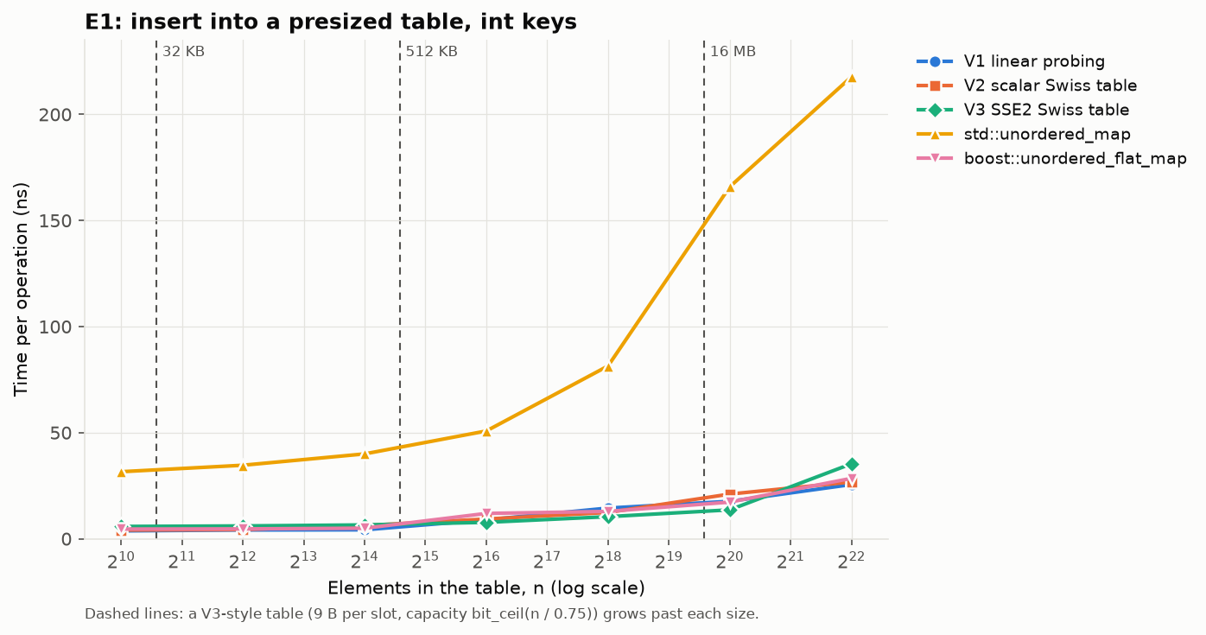
std::unordered_map performs significantly worse when inserting int keys, and this gap widens as the elements in the table grow. At small number of elements, this is likely due to the extra indirection in using a linked list causing memory accesses to take longer. As elements in the table grow, the chance of cache misses grows significantly. Open addressing maps are likely significantly faster due to memory accesses being quicker and more likely to be on cache for contiguous memory addresses.

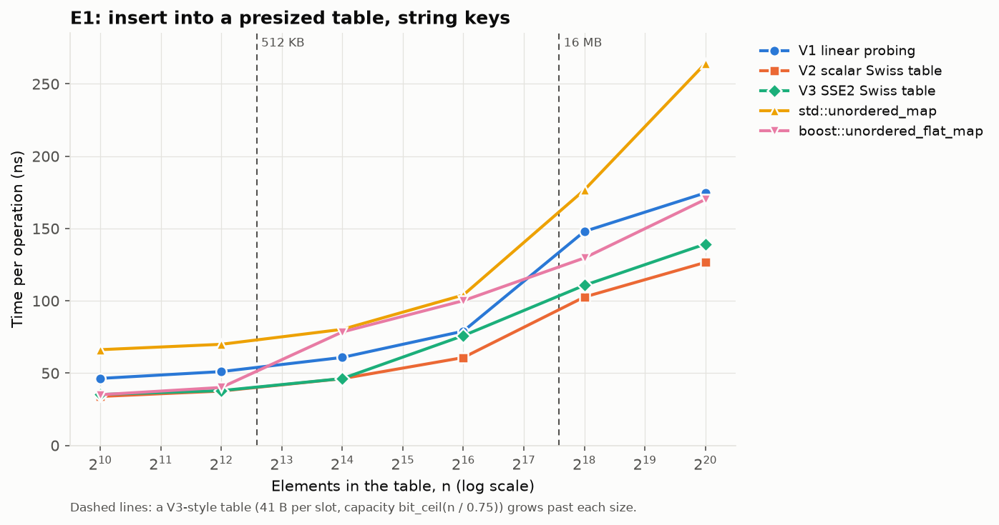
The gap is significantly narrower for the insertion of string keys. This is probably due small string optimisation in libstdc++ allocating new memory once strings are above 15 characters. This causes the memory to be non-contiguous even for the open addressing maps, significantly reducing memory access performance.

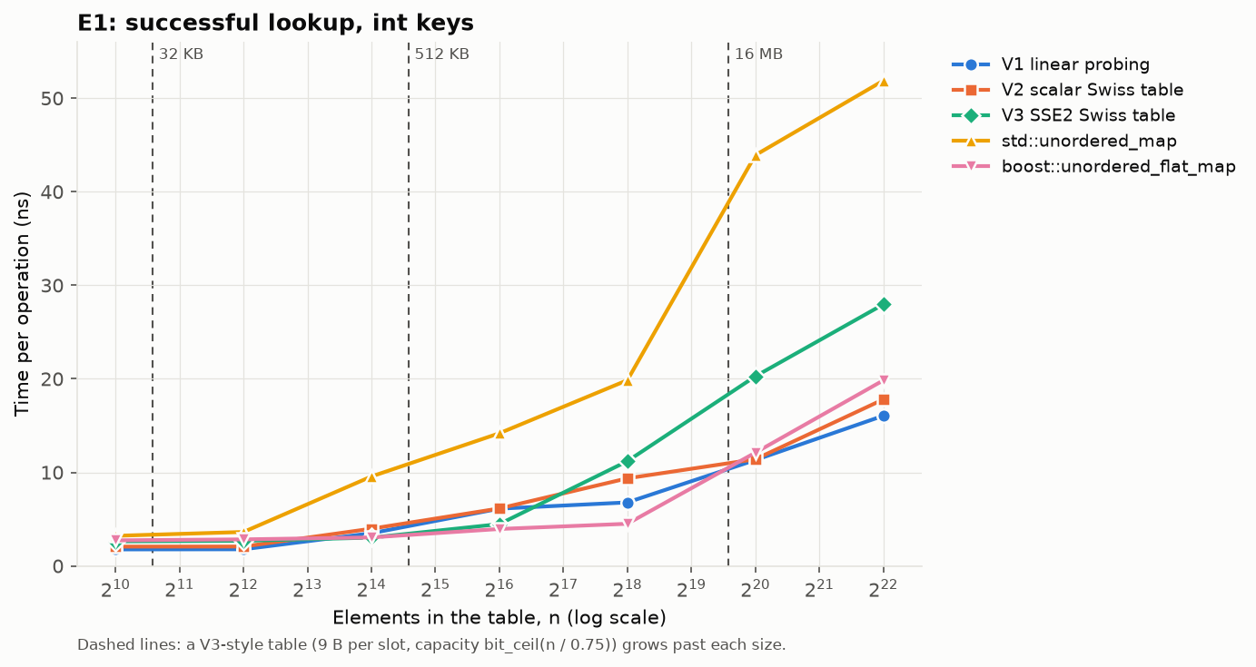
Surprisingly, the V3 Swiss Table performs worse once the table becomes large enough. A possible explanation is that V3’s implementation prevents memory-level parallelism, since a hit’s index is only known after the memory is returned, whilst V2 is able to allow the CPU to predict a match between the control byte and the key comparison, so loads both from RAM. V1 only directly compares, and since comparing ints is cheap, it doesn’t have to wait for memory from the control byte to be loaded before comparing keys directly. Boost’s map also shows a trend of performing worse at higher levels, likely due to the same reasons as V3.

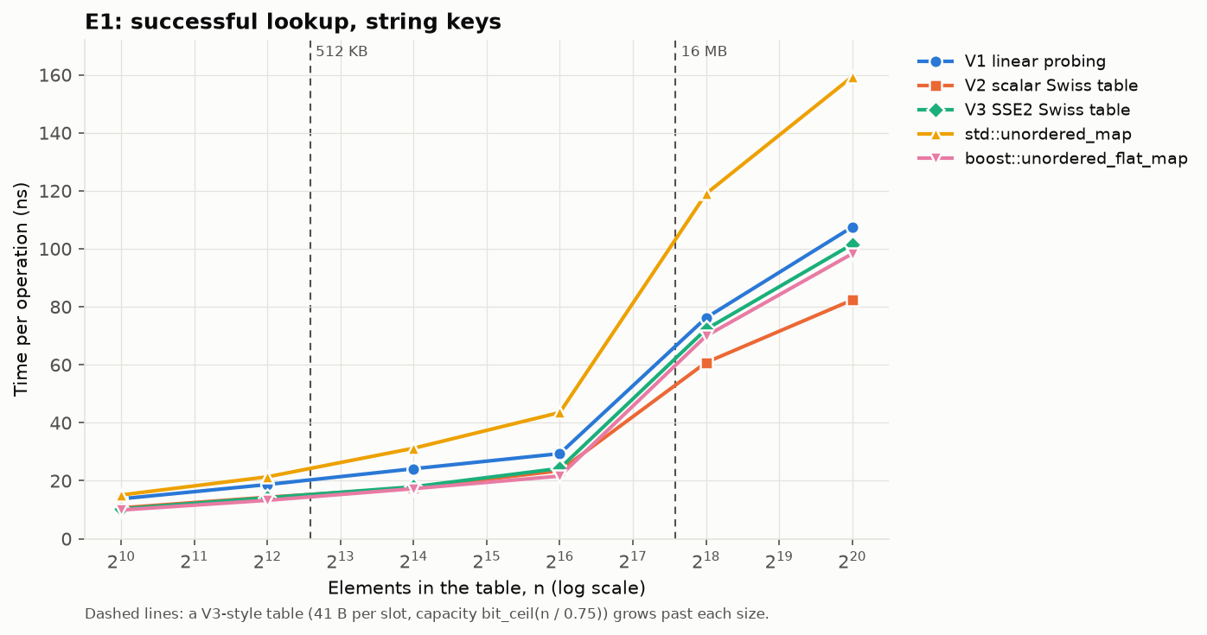
Here the gap closes again. V1 likely got significantly worse due to having to directly compare string keys. V2 outperforms all maps, likely because it allows the memory-level parallelism whilst also preventing direct key comparisons. The reason the gap between V3 and Boost has narrowed is likely due to Boost only fetching the first cache line of slots
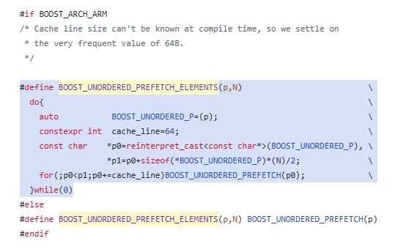
(boostorg, n.d.) thus a string hit is less likely as less strings can be loaded.

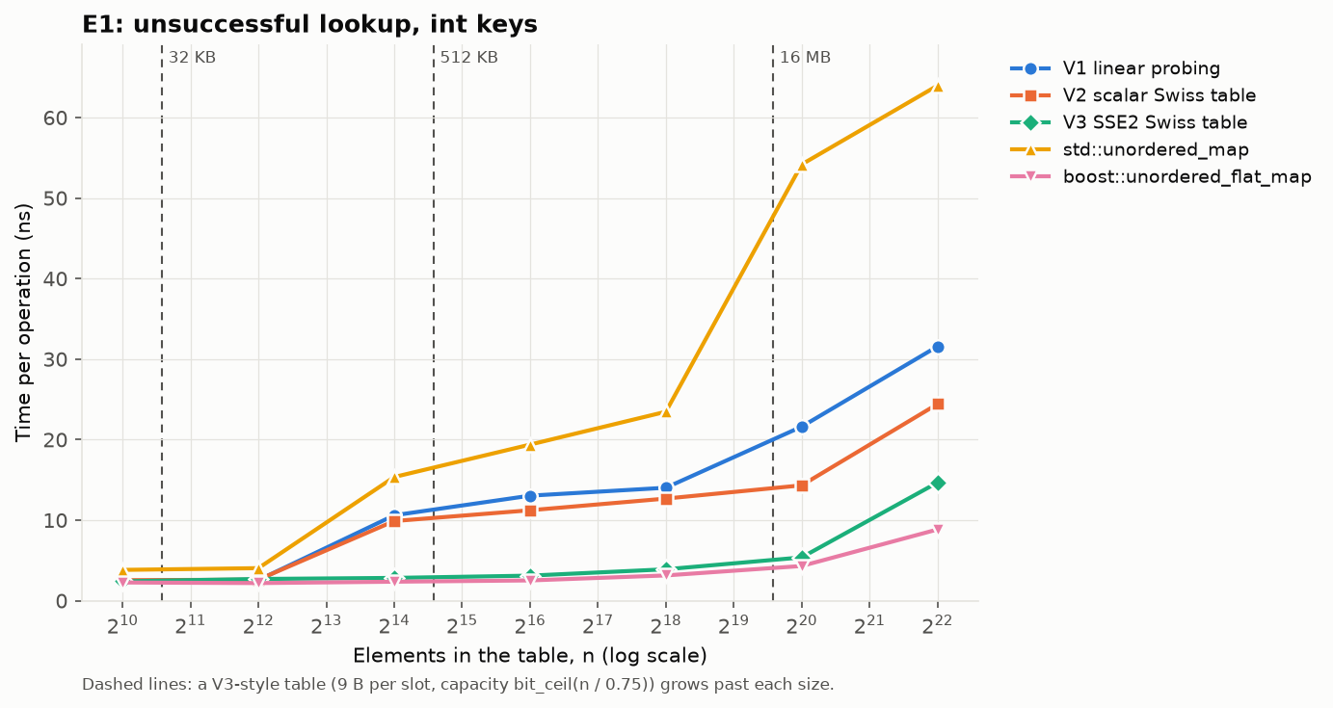
Here we have an expected result, with performance ordered std::unordered_map, V1, V2, V3, and Boost. The difference in trends between unsuccessful lookup and successful lookup is likely due to misses having a higher expected value of slots that need to be examined. At load factor 0.5, we expect around 2.5 slots needed to be searched for a miss vs 1.5 for a hit. This leads to branch prediction being less effective in the missed case, thus the advantages of SIMD create the expected gap.

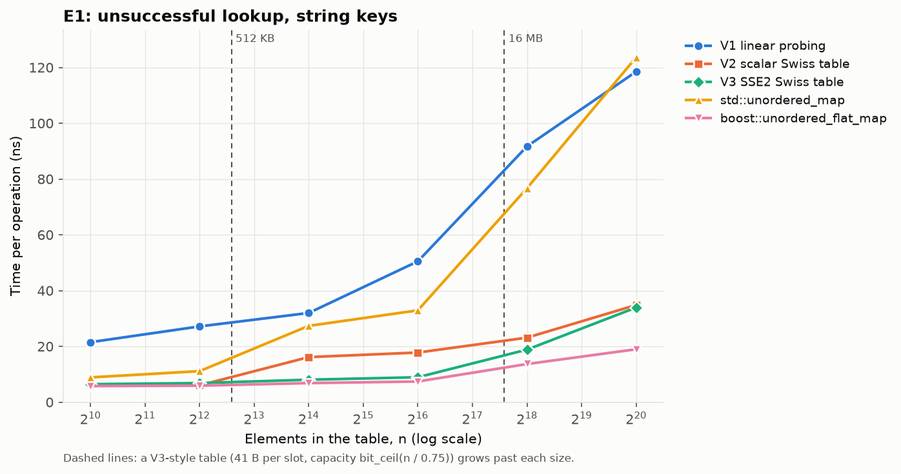
We see a similar trend as with int, except V1’s performance is significantly worse. This again is likely due to having to compare more strings on misses, which is very costly.

Experiment 2:
Measures average time for successful and unsuccessful lookup of int keys dependent on the load factor. std::unordered_map was excluded, as load factor is a different quantity for closed addressing tables. Moreover, Boost’s table has a max load factor of 0.875 that cannot be modified, so its line is cut short. Plotted results are below.

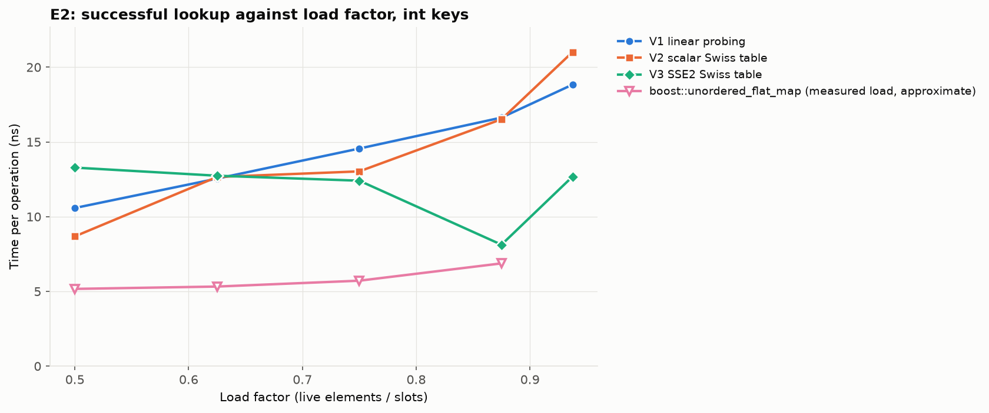
V1, V2. This is expected as the expected number of slots needing to be examined is proportional to the load factor. However, strangely, V3 gets better until around 0.88, where it starts getting worse again. A possible explanation is that the expected value of slots needing to be examined never goes above 16 for the load factors tested in this experiment. Thus, since 16 are processed simultaneously, the performance is largely uncorrelated with the load factor, and this trend of performing better is just an outlier. We also observe Boost barely getting worse, supporting this claim since both utilise SIMD.

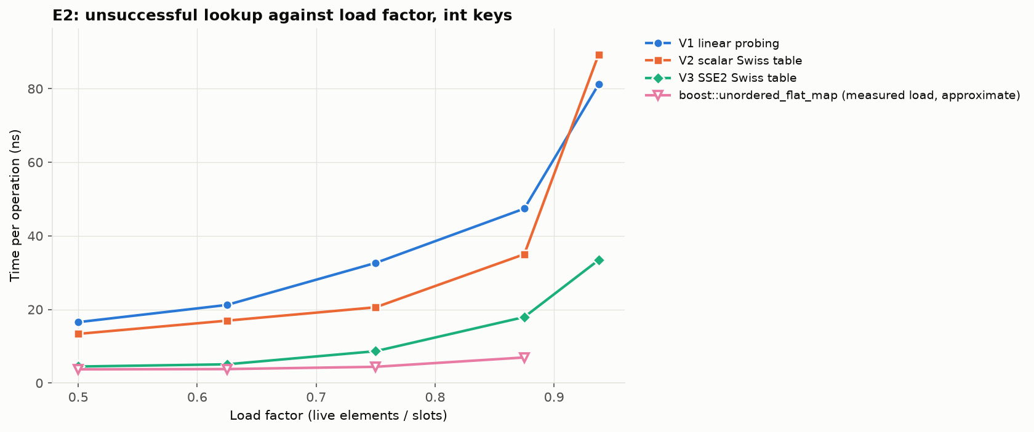
We now see V3 noticeably getting worse at around 0.88, this is the point where the expected value of slots examined for misses starts growing rapidly. As stated in the hypothesis, at load factor 0.875 and 0.9375, the expected value is 32.5 and 128.5 respectively. Thus multiple groups are expected to be checked, worsening runtime. The effect is more pronounced in V1 and V2, where they have to check each slot linearly, whilst V3 only needs to do 1/16th of the work. We also observe V2 performing worse than V1 at load factors above 0.9, this is likely due to the control array leading to false matches. The chance of a false match is 1/128, so at high load factors such as 0.9375, over 128 slots need to be examined, making false matches likely. False matches can cause a branch misprediction and a load from slots, costing time in unnecessary memory fetched. Since keys are just ints, it is likely that the cost from false matches outweighs the cost of direct comparisons.

(c) What I learned:
I was initially surprised that open addressing maps perform better on average than closed addressing maps. It seemed to me that traversing buckets using linked lists reduced the size of clusters, so I thought that the number of operations would be lower on average and thus perform better. However, the results vastly contradict that, and forced me to explore how cache lines and memory fetches dictate performance more so than number of operations. Contiguously stored data is able to be loaded into cache lines all at once, vastly improving speed. Moreover, multiple operations can be done simultaneously. It made me realise the gap between algorithmic knowledge where we try to minimise steps, and how actual hardware works, where something can be vastly more performant even though it is algorithmically less optimal.

I learnt that instead of getting the index by modding the hash by the capacity or a prime number, you can get an index through bitmasking tricks, where you keep capacity as a power of 2, then (capacity - 1) can be used as a mask with any hash to get a number between 0 and (capacity - 1). This is efficient since the bitmask & operator is much more performant than the % operator.

I learnt what a CMake file is for, and how to build projects using them.

Moreover, I learnt a significant amount of the C++ language and general best practices. I had to learn how to implement operator overloading to create the iterators, learn pointer arithmetic to advance the pointers in the iterators, learn move semantics, and intrinsic functions. I learnt that strings of length 16 or greater aren’t allocated as one contiguous block but actually holds a pointer to a dynamic char array. Moreover, I learnt the specifics about compilation and linking works, and how header files get copy and pasted into any file that includes them. The reason they work is that just provide declarations of functions, allowing the compiler to know that calling a function is permissible, and the linker links the call of the function with the actual implementation of it. How templated classes aren’t actually compiled but instead are instructions to create a class of a type, which is why they can’t have a corresponding implementation file.

Lastly, I learnt that AI tools do actually frequently make pretty trivial mistakes. Reflecting, I think I’ve placed too much confidence on them without proper review, and has made me appreciate how subtle errors can slip through if someone misuses these tools.

(d) AI use:

Which tools you used:
Claude and Claude Code.

What you used them for:
I used Claude to assist with creating the map files. I used it mostly for code review and when I got stuck with implementation as I wanted to implement the maps myself to really understand how they worked. I also used Claude to write any mistakes it did so I could append it to ai-failures.md in my repo. I used Claude to generate Google test files for my unit tests. I used Claude to create the SplitMix64 hashing function.I asked it for prompts to Claude Code. Lastly, I used it to help me with the initial research in understanding how Swiss Tables work and analysis of open addressing tables, such as Knuth’s analysis.
I used Claude Code to write the Google benchmark file, the plot.py file, the CMake file, and to do git commands.

At least two specific examples of where the AI was wrong, unhelpful, or misleading:
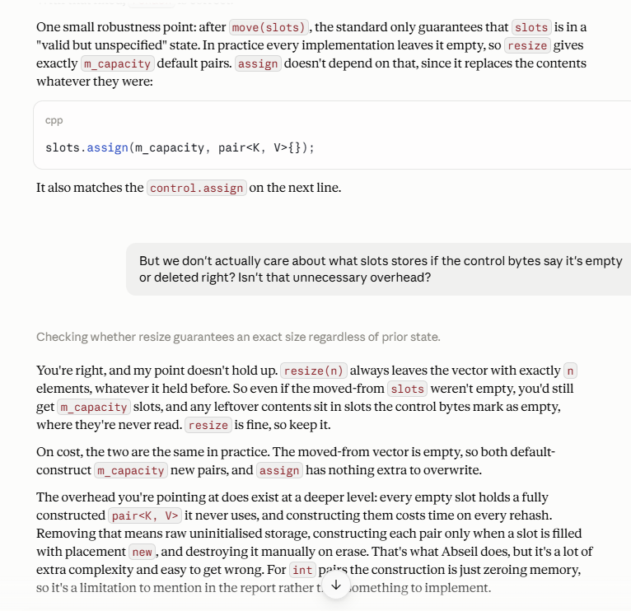

In my Scalar_Swiss_Map::rehash() function, Claude suggested I replace slots.resize(m_capacity) to slots.assign(m_capacity, pair<K, V>{});, which is unnecessary since slots can hold garbage values for empty or deleted slots, as long as the control vector correctly identifies them as empty or deleted, and as such, they will never be accessed. Default initialising the pair just creates unnecessary overhead. In response, I immediately questioned Claude and asked for clarification, as I might have been missing something.

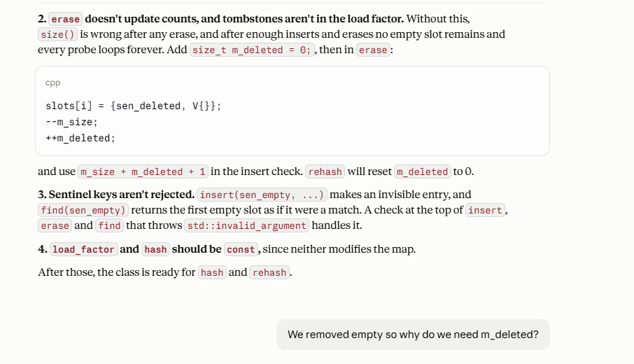
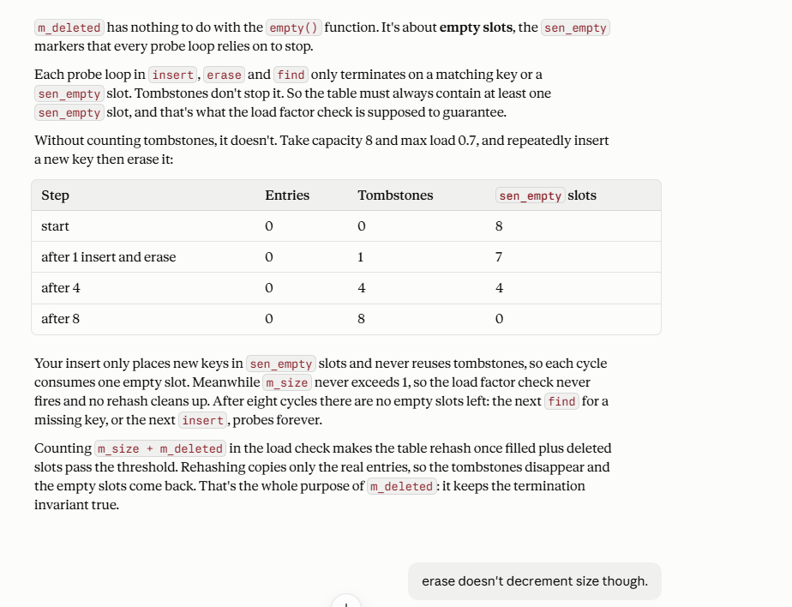
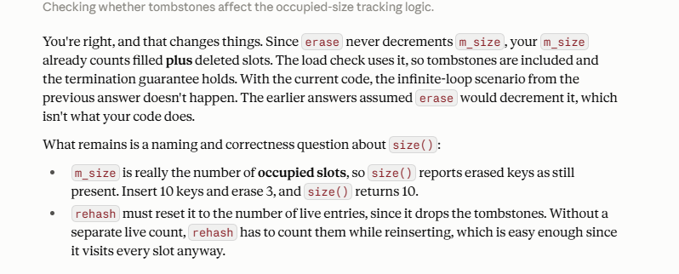

Here, Claude misinterpreted a variable. It was meant to mark the number of occupied slots, either filled with a key or tombstones, to inform when we’ve reached our maximum load factor. However, Claude misinterpreted this as active keys. Adding m_deleted would do nothing for actual functionality, so it was just unnecessary. In these situations, I always try to push back to see if there’s a technical or best practice reason for what Claude is suggesting. In this example, Claude admitted that it made a mistake, and we moved on.

What you understood vs what you took on trust:
I understood how the three maps I implemented work.

I mostly took on trust that it verified edge cases when creating the Google test files, the Google benchmark file, plot.py, and CMake files were implemented correctly. Moreover, the SplitMix64 hashing was implemented correctly and distributed its entropy evenly. I trusted Claude’s findings on Knuth’s analysis of the expected number of slots that need to be visited for a hit and a miss.

References:

5.2 $ Linear Hash Table: Linear Probing. (n.d.). Open Data Structures. Retrieved https://opendatastructures.org/ods-cpp/5_2_Linear_Probing.html
Anderson, R. (2022, January 31). Lecture 11: More hashing. https://courses.cs.washington.edu/courses/cse332/22wi/lectures/cse332-22wi-lec11-HashingII-noHiddenSlides.pdf
boostorg. (n.d.). Unordered/include/boost/unordered/detail/foa/core.Hpp at develop · Boostorg/unordered. GitHub. Retrieved September 30, 2026, from https://github.com/boostorg/unordered/blob/develop/include/boost/unordered/detail/foa/core.hpp

